有機三第一次段考

日期2022年10月28號星期五

學號: 姓名: 總分: /294

一、選擇題(共21題，每題6分，共126分)

1. Which of the following structure cannot be the expected structure after hydrolysis of amygdalin. (C)

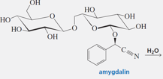



2. Which of the following statements for D-Psicose, D-Fructose and D-Glucose is **correct**? (B)

 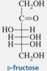

(A) D-Psicose and D-Fructose C2-epimers

(B) D-Glucose can be converted to D-Fructose thru ene-diol intermediate

(C) D-Glucose can be converted to D-Psicose by enzymatic catalysis

(D) D- Fructose can be converted to D-Psicose by enzymatic catalysis

(E) D-Psicose and D-Fructose become meso compounds after treatment with nitric acid

3. Treatment of L-gulose with NaBH4 led to D-glucitol. Which of the following hexose would lead exclusively to the same D-glucitol after NaBH4 reduction? (A)

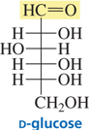 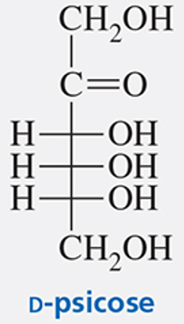

1. D-Glucose (B) D-Mannose (C) D-galactose (D) D-fructose (E) D-Psicose

4. Which natural amino acid is responsible for the generation of of ethene in plants? (E)



5. What is the correct cyclic structure of D-galactose? (E)



6. Which of the following structures **is not expected** intermediate or product for the reaction of ninhydrin with a give amino acid? (D)

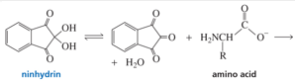



7. Which one of the following structures cannot be expected product for the t-Boc deprotection by CF3CO2H? (B)

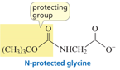



8. Provide the correct structure of the following transformation. (D)





9. Which of the following compounds do not possess intermolecular hydrogen bondings? (A)

1. Amylose (B) Cellulose (C) Chitin (D) protein alpha-helix (E) protein beta-sheet

10. When a nonapeptide undergoes partial hydrolysis, it forms dipeptides, two tripeptide and one tetrapeptides whose amino acid compositions are shown. Reaction of the intact nonapeptide with Edman’s reagent releases PTH-Leu.

**1.** Pro, Ser **3.** Met, Ala, Leu **5.** Glu, Ser, Val, Pro **7.** Met, Leu

**2.** Gly, Glu **4.** Gly, Ala **6.** Glu, Pro, Gly **8.** His, Val

The first five AA sequence is analyzed to be: (B)

(A) Leu-Met-Ala-Glu-Gly-Pro (B) Leu-Met-Ala-Gly-Glu-Pro (C) Leu-Ala-Met-Gly-Glu-Pro (D) Leu-Ala-Met-Gly-Pro-Glu (e) Leu-Met-Ala-Gly-Ser-Pro

11. **a.** How long is an a-helix that contains 74 amino acids? (A)

**b.** How long is a fully extended peptide chain that contains the same number of amino acids?

(The distance between consecutive amino acids in a fully extended chain is 3.5 A; the repeat distance of an alpha-helix is 5.4 A.)

(A) **a**: 110 and **b**: 260 Å (B) **a**: 110 and **b**: 220 Å (C) **a**: 130 and **b**: 260 Å (D) **a**: 110 and **b**: 130 Å (E) **a**: 130 and **b**: 220 Å

12. Which one of the following structures **cannot be** expected product? (D)

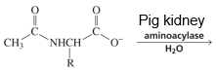



13. Which of the following is not the expected intermediate for the designated trans isomer of the reactant? (D)

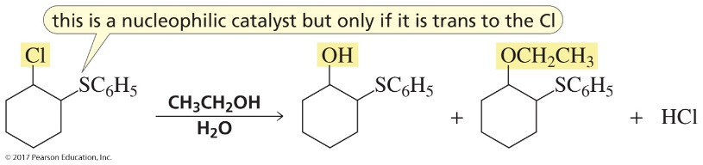



14. The Lys-229 and Asp-33 at the active site of aldolase that are responsible for the metabolism of D-fructose-1,6-bisphosphate to D-glyceraldehyde-3-phosphate and dihydroxyacetone phosphate. Which one is the correct description for the catalytic roles of these two residues? (C)

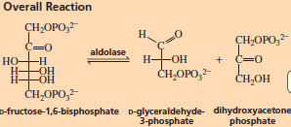 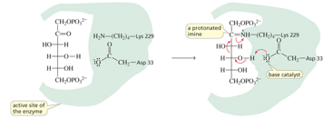

(A) Lys-229 as a general base in retro-aldol. (B) Asp-33 as a general acid in C=O activation. (C) Lys-229 reacts in Schiff base formation. (D) Asp-33 as a general Base in E1CB. (E) Lys-229 as a general acid in enamine protonation.

15. Which of the following is the correct protonated structure? (C)

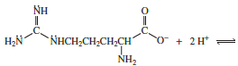



16. In what order would histidine, serine, aspartate, and valine be eluted with a buffer of pH 4 from a column containing an anion-exchange resin (Dowex 1)? (B)

(A) His, Ser, Asp, Val (B) His, Val, Ser, Asp (C) His, Ser, Val, Asp (D) His, Val, Asp, Ser (E) Asp, Val, Ser, His

17. Provide the other reagent to react with dimethyl 2-bromomalonate so a given racemic amino acid can be efficiemtly prepared. (B)



18. What would be the final byproduct of the following DCC activation followed by treatment with a given amino acid? (A)

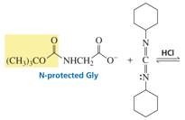



19. Which one of the following structures is the correct intermediate during the Edmin degradation of the N-terminal amino group. (E)





20. Which of the following is not a stabilizing interaction factor for the tertiary structure of a given protein? (B)

(A) S-S covalent bonds (B) amide-amide folding (C) hydrogen bonds (D) electrostatic attractions (E) hydrophobic interactions

21. What is the key intermediate for the following reaction with iodide as the nucleophilic catalysis. (E)



(A) CH3CH2OH2 (B) HO-I (C) CH3CH2Cl-I (D) CH3CH2O-I (E) CH3CH2I

二、非選擇題（共14題每題12分，共168分）

1. (A) Provide the correct product structure by the sequence of Wohl degradation. (B) Which D-hexose would lead to the same product after the same sequence of transformations?

 Ans:  D-mannose

2. (A) Provide the correct product structures of the following transformations. (B) What are the correct product structures after their further oxidative with Br2, H2O?

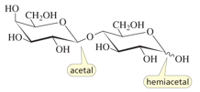 Ans: 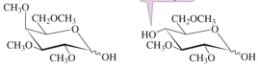

3. (A) Which OH group in vitamin C possesses the most acidic proton? (B) Explain why?

 Ans: 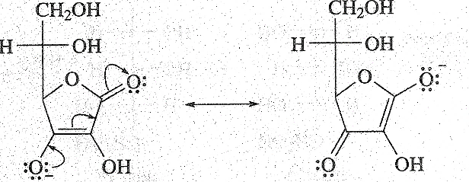

4. Propose a mechanism for the rearrangement that converts an alpha-hydroxyimine to an alpha-aminoketone in the presence of a trace amount of acid.

Ans:

5. Calculate the expected pI values of the following two compounds.

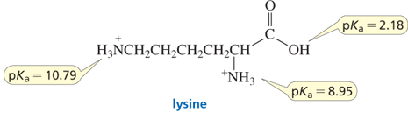 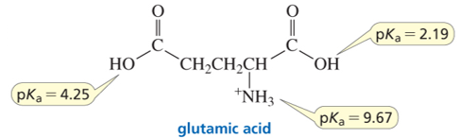

Ans: 9.87; 3.22

6. Provide a suitable reaction mechanism for the following reaction.

 Ans: 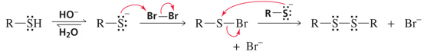

7. Cyanogen bromide causes the hydrolysis of the amide bond on the C-side of a methionine residue. Provide the key intermediates and products of the following transformation followed by acid hydrolysis. (10 pts)

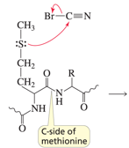

8. **a.** Draw the mechanism for the following reaction if it involves specific-acid catalysis.

**b.** Draw the mechanism if it involves general-acid catalysis.

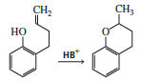Ans: 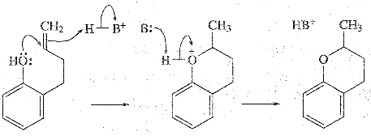 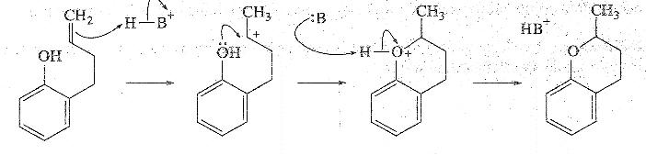

9. Explain why Cu2+ can facilitate the following decarboxylation?

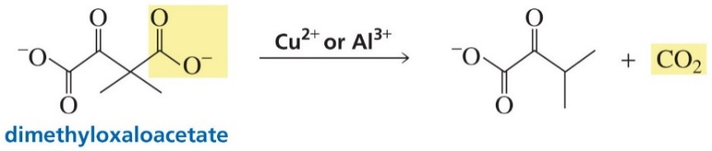Ans: 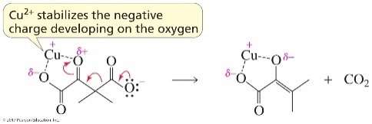

10. The *ortho*-carboxy substituent in **B** acts as an intramolecular *nucleophilic catalyst* instead of an intramolecular *general-base catalyst* in **A** in ester hydrolysis. Propose a reasonable mechanism for the hydrolysis of **B**.



Ans: 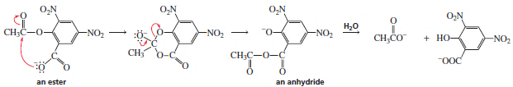

11. Lysozyme is an enzyme that destroys bacterial cell walls. The two key Glu-35 and Asp-52 are involved in the active sire responsible for the glycosidic retentive hydrolysis. Propose a reasonable mechanism. Where would be the O18 resides if one uses O18-lablled H2O?



Ans: 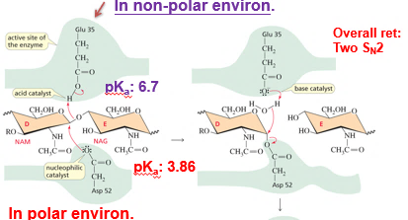

12. 2-Acetoxycyclohexyl tosylate reacts with acetate ion to form 1,2-cyclohexanediol diacetate. The reaction is stereospecific—that is, the stereoisomers obtained as products depend on the stereoisomer used as a reactant. Recall that because 2-acetoxycyclohexyl tosylate has two asymmetric centers, it has four stereoisomers—two are cis and two are trans. Explain the following observations:

**a.** Both cis reactants form an optically active trans product, but each cis reactant forms a different trans product.

**b.** Both trans reactants form the same racemic mixture.

**c.** A trans reactant is more reactive than a cis reactant.

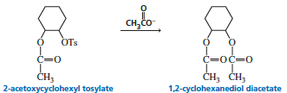

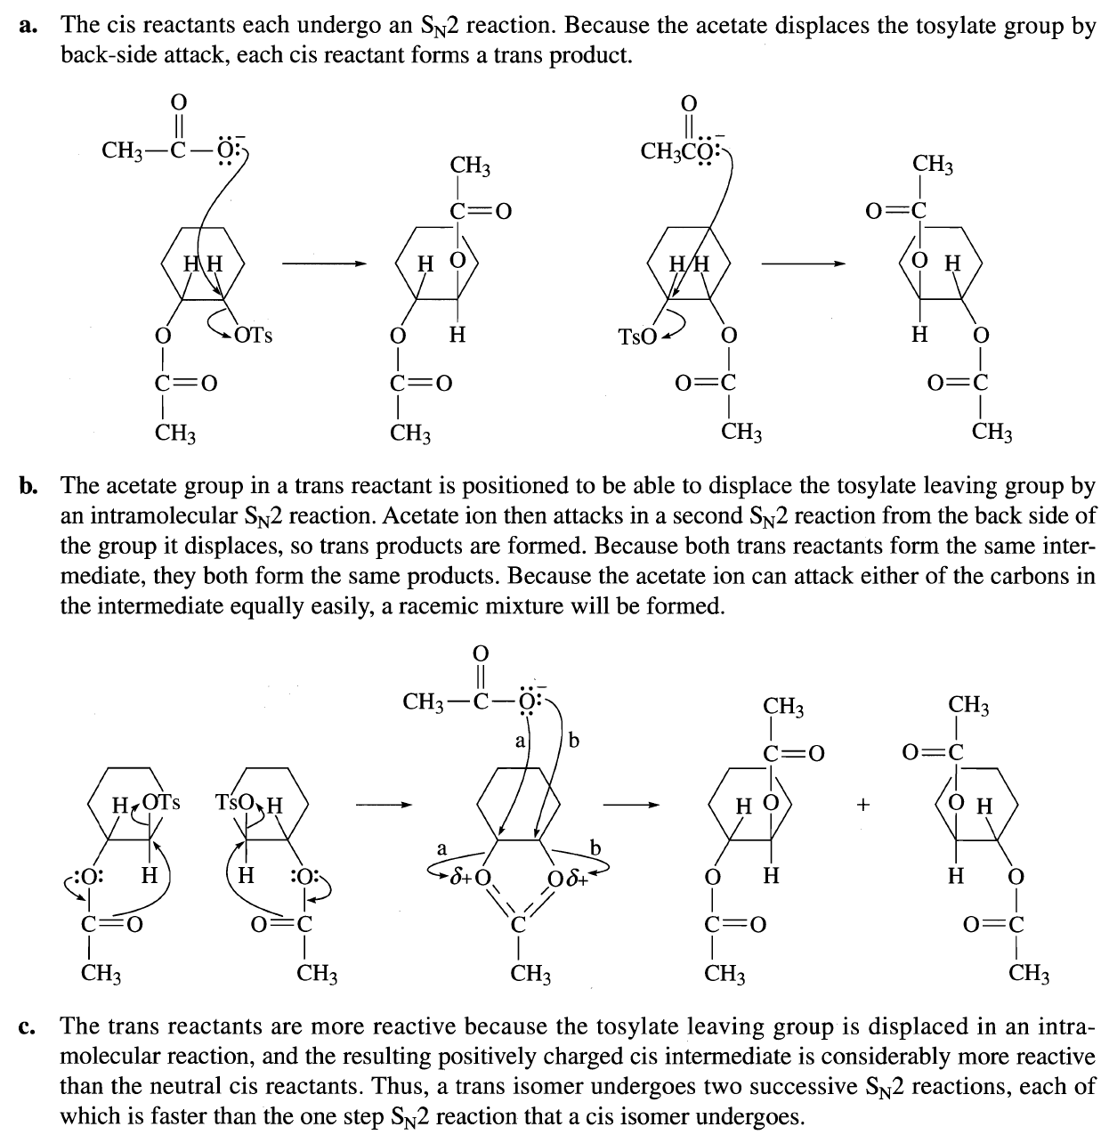

13. Which of the following two compounds eliminates HBr more rapidly in a basic solution? Explain why?

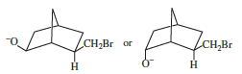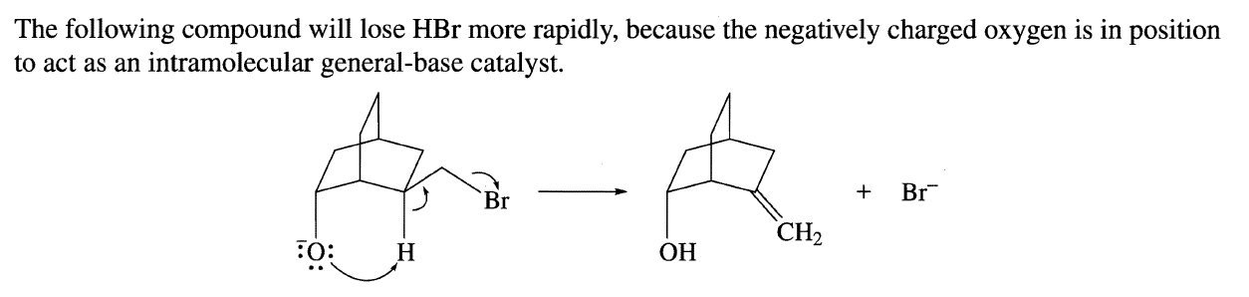

14. Which compound forms an anhydride more rapidly? Explain why?

